AGENDA

Meeting | Budget and Performance Committee
Date | Tuesday 13 January 2015
Time | 10.00 am
Place | Chamber, City Hall, The Queen's Walk, London, SE1 2AA
Copies of the reports and any attachments may be found at
www.london.gov.uk/mayor-assembly/london-assembly/budget-performance

Most meetings of the London Assembly and its Committees are webcast live at www.london.gov.uk/mayor-assembly/london-assembly/webcasts where you can also view past meetings.

Members of the Committee

John Biggs AM (Chairman)
Stephen Knight AM (Deputy Chair)
Gareth Bacon AMDarren Johnson AMJoanne McCartney AMValerie Shawcross CBE AMRichard Tracey AM

A meeting of the Committee has been called by the Chairman of the Committee to deal with the business listed below.
Mark Roberts, Executive Director of Secretariat
Monday 5 January 2015
Further Information
If you have questions, would like further information about the meeting or require special facilities please contact: Dale Langford, Principal Committee Manager; Telephone: 020 7983 4415; Email: dale.langford@london.gov.uk; Minicom: 020 7983 4458.

For media enquiries please contact Alison Bell; Telephone: 020 7983 4228;
Email: alison.bell@london.gov.uk. If you have any questions about individual items please contact the author whose details are at the end of the report.

This meeting will be open to the public, except for where exempt information is being discussed as noted on the agenda. A guide for the press and public on attending and reporting meetings of local government bodies, including the use of film, photography, social media and other means is available at www.london.gov.uk/sites/default/files/Openness-in-Meetings.pdf.

There is access for disabled people, and induction loops are available. There is limited underground parking for orange and blue badge holders, which will be allocated on a first-come first-served basis. Please contact Facilities Management on 020 7983 4750 in advance if you require a parking space or further information.

If you, or someone you know, needs a copy of the agenda, minutes or reports in large print or Braille, audio, or in another language, then please call us on 020 7983 4100 or email assembly.translations@london.gov.uk.

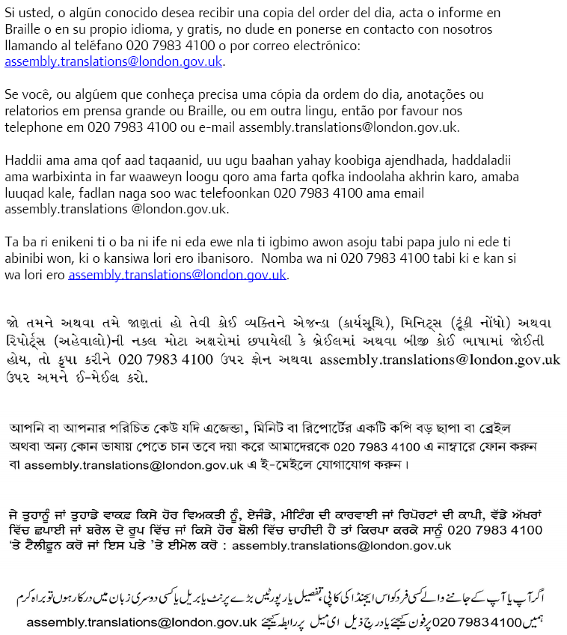

Agenda
Budget and Performance Committee
Tuesday 13 January 2015

- Apologies for Absence and Chairman's Announcements

To receive any apologies for absence and any announcements from the Chairman.

- Declarations of Interests (Pages 1 - 4)

The Committee is recommended to:

(a) Note the list of offices held by Assembly Members, as set out in the table at Agenda Item 2, as disclosable pecuniary interests;

(b) Note the declaration by any Member(s) of any disclosable pecuniary interests in specific items listed on the agenda and the necessary action taken by the Member(s) regarding withdrawal following such declaration(s); and

(c) Note the declaration by any Member(s) of any other interests deemed to be relevant (including any interests arising from gifts and hospitality received which are not at the time of the meeting reflected on the Authority’s register of gifts and hospitality, and noting also the advice from the GLA’s Monitoring Officer set out at Agenda Item 2) and to note any necessary action taken by the Member(s) following such declaration(s).

- The 2015/16 GLA Group Budget (Pages 5 - 8)

Report of the Executive Director of Secretariat
Contact: Steve Wright; steve.wright@london.gov.uk; 020 7983 4390

The Committee is recommended to:

- Note the report, put questions to the Mayor and senior GLA officers on the 2015/16 GLA Group Budget and note the discussion;

- Delegate authority to the Chairman, in consultation with party Group Lead Members, to agree the Committee’s response to the Mayor’s Draft Consultation Budget for 2015/16.

- Budget and Performance Committee Work Programme (Pages 9 - 12)

Report of the Executive Director of Secretariat
Contact: Steve Wright; steve.wright@london.gov.uk; 020 7983 4390

The Committee is recommended to note its work programme for 2014/15.

- Date of Next Meeting

The next meeting of the Committee is scheduled for Thursday 19 March 2015 at 10.00am in Committee Room 5.

- Any Other Business the Chairman Considers Urgent

